DEEP LEARNING

Deep Learning is transforming the way machines understand, learn and interact with complex data. Deep learning mimics neural networks of the human brain, it enables computers to autonomously uncover patterns and make informed decisions from vast amounts of unstructured data.

Example Uses
- Face recognition
- Voice assistants
- Self-driving cars
- Chatbots
- Medical diagnosis
- Recommendation systems
Working of Deep Learning
Neural network consists of layers of interconnected nodes or neurons that collaborate to process input data. In a fully connected deep neural network data flows through multiple layers where each neuron performs nonlinear transformations, allowing the model to learn intricate representations of the data.
In a deep neural network the input layer receives data which passes through hidden layers that transform the data using nonlinear functions. The final output layer generates the model’s prediction.
Machine Learning vs Deep Learning
Machine learning and Deep Learning both are subsets of artificial intelligence but there are many similarities and differences between them.

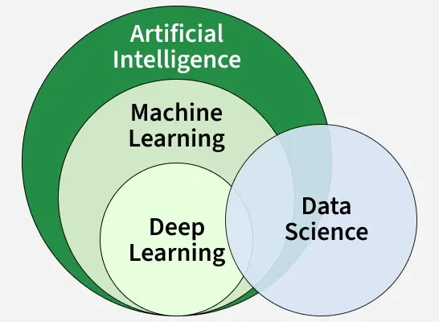

Aspect | Machine Learning | Deep Learning
Basic Idea | Applies statistical algorithms to learn patterns from data | Uses artificial neural networks to learn patterns from data
Data Requirement | Works well with small to medium datasets | Requires a large amount of data
Task Complexity | Better for simple and low-label tasks | Better for complex tasks like image and text processing
Training Time | Takes less time to train | Takes more time to train
Feature Extraction | Features are manually selected and extracted | Features are automatically extracted
Learning Process | Not end-to-end | End-to-end learning
Model Complexity | Less complex | Highly complex
Interpretability | Easy to understand and explain | Hard to interpret (black box)

Basic Structure of Deep Learning
A deep learning model mainly contains:
Input Layer → Hidden Layers → Output Layer
🔹 Input Layer
Receives data like images, text, audio, etc.
🔹 Hidden Layers
Processes and learns patterns.
🔹 Output Layer
Gives final prediction/result.

Workflow of Deep Learning
Deep Learning Workflow

Data Collection
↓
Data Preprocessing
↓
Model Selection
↓
Training the Model
↓
Validation & Testing
↓
Prediction/Deployment

Step-by-Step Explanation
1️⃣ Data Collection
Collect large datasets.
Examples:
- Images
- Audio
- Videos
- Text files

2️⃣ Data Preprocessing
Clean and prepare data.
Includes:
- Removing noise
- Handling missing values
- Resizing images
- Normalization

3️⃣ Model Selection
Choose suitable neural network architecture.
Example:
- CNN for images
- RNN for text
- Transformer for NLP

4️⃣ Training the Model
The model learns patterns using training data.
Important concepts:
- Epoch
- Batch size
- Loss function
- Optimizer

5️⃣ Validation & Testing
Check model accuracy using unseen data.
Metrics:
- Accuracy
- Precision
- Recall
- F1-score

6️⃣ Deployment
Use the trained model in real applications.
Example:
- Mobile apps
- Websites
- Robots

Types of Deep Learning Networks
1️⃣ Artificial Neural Network (ANN)
Description
Basic deep learning model inspired by the human brain.
Used For
- Classification
- Prediction
- Regression
Workflow
Input Data
↓
Hidden Layers
↓
Output Prediction
Example
Student pass/fail prediction.

2️⃣ Convolutional Neural Network (CNN)
Description
Specialized for image processing.
Used For
- Image recognition
- Face detection
- Medical imaging
Workflow
Image Input
↓
Convolution Layer
↓
Pooling Layer
↓
Fully Connected Layer
↓
Output
Features
- Detects edges, shapes, objects
- High accuracy in computer vision

3️⃣ Recurrent Neural Network (RNN)
Description
Designed for sequential data.
Used For
- Speech recognition
- Language translation
- Time series prediction
Workflow
Sequential Input
↓
Memory Processing
↓
Prediction
Key Feature
Remembers previous information.

4️⃣ Long Short-Term Memory (LSTM)
Description
Improved version of RNN.
Used For
- Text generation
- Weather prediction
- Stock market forecasting
Advantage
Handles long-term dependencies better.

5️⃣ Autoencoder
Description
Learns compressed representations of data.
Used For
- Data compression
- Noise reduction
- Feature learning
Workflow
Input
↓
Encoder
↓
Compressed Representation
↓
Decoder
↓
Reconstructed Output

6️⃣ Generative Adversarial Network (GAN)
Description
Two neural networks compete with each other.
Used For
- Fake image generation
- AI art
- Deepfake technology
Workflow
Generator → Creates Fake Data
Discriminator → Checks Real/Fake

7️⃣ Transformer Networks
Description
Modern architecture used in NLP.
Used For
- Chatbots
- Language translation
- Large language models
Examples
- ChatGPT
- BERT
- GPT
Advantages
- Faster training
- Better understanding of context

Important Concepts in Deep Learning
Epoch
One complete pass through training data.
Batch Size
Number of samples processed at once.
Learning Rate
Controls how fast the model learns.
Activation Function
Adds non-linearity.
Examples:
- ReLU
- Sigmoid
- Tanh

Advantages of Deep Learning
High accuracy
Learns automatically from data
Handles huge datasets
Excellent for images and text
Reduces manual feature engineering

Disadvantages of Deep Learning
Requires large datasets
Needs powerful hardware (GPU)
Training takes time
Hard to interpret sometimes
Expensive computational cost

Difference Between Machine Learning & Deep Learning
Machine Learning | Deep Learning
Needs feature engineering | Learns features automatically
Works with small data | Needs large data
Faster training | Slower training
Simpler models | Complex neural networks
Lower computational power | Requires GPUs

Popular Deep Learning Frameworks
- TensorFlow
- PyTorch
- Keras
- MXNet

Simple Real-Life Example
Cat vs Dog Image Classification
Workflow:
Collect Images
↓
Preprocess Images
↓
Train CNN Model
↓
Model Learns Features
↓
Test Accuracy
↓
Predict Cat or Dog

Conclusion
Deep Learning is a powerful technology that enables machines to learn complex patterns from massive data. It is widely used in modern AI systems such as:
- Image recognition
- Chatbots
- Recommendation systems
- Autonomous vehicles
- Natural language processing
It mainly uses neural networks like:
- ANN
- CNN
- RNN
- LSTM
- GAN
- Transformers
These models follow a workflow involving:
- Data collection
- Preprocessing
- Training
- Testing
- Deployment

